КЗ «Черешенська спеціалізована школа-інтернат І-ІІІ ступенів з поглибленим вивченням окремих предметів та курсів»

План-конспект уроку в 10 класі

Підготувала та провела:
вчитель англійської мови Куліш О.Є.
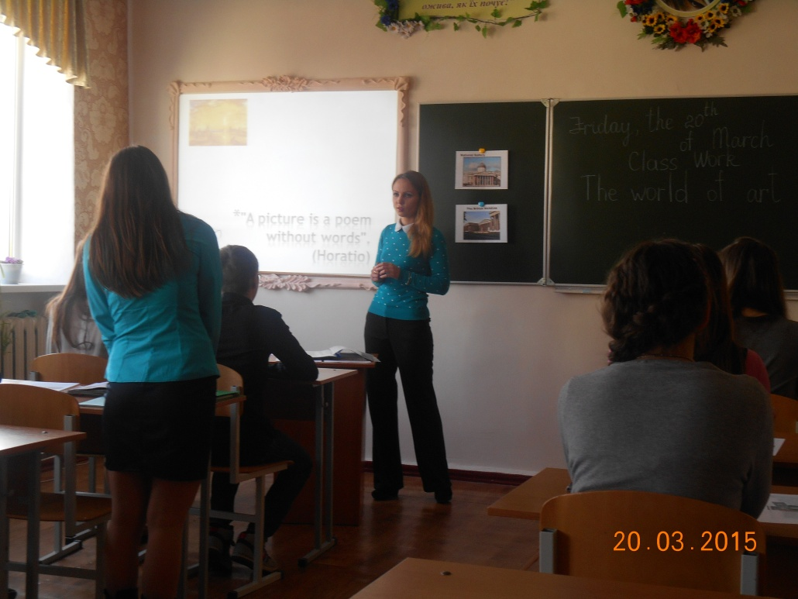

Objectives:
- to enrich students' vocabulary on the topic "The World of Painting";
- to develop students' reading, listening and speaking skills;
- to provide students with additional information about famous Ukrainian museums and painters;
- to consolidate the knowledge used in History and Arts lessons.

PROCEDURE
I.INTRODUCTION. WARMING- UP
T: Dear friends, today we'll continue to study the topic “The World of Painting". The quotes describe the importance of the whole process for a person called painter.
There are literally thousands of art galleries all over the world. Almost every city has an art gallery but there are some art galleries that are known all around the world. People will travel across the world just to see some of these famous art galleries and the master pieces that they house inside.
Explain the following:
"A picture is a poem without words". (Horatio)

Art as an expression of our culture, thought process and creativity has no parallel. Viewing these masterpieces in an art gallery transposes the viewer into the mind and time of the creator who has shaped our culture.

II. MAIN PART
I. DISCUSSION
T: Art is actually all around you, in every shape and form. Many people prefer going to museums to watching TV. Why do people go to museums and art galleries?
Visiting the galleries can be a fascinating visit through the past few decades and shows how much style and taste has changed.
Answer the questions:
- Are you interested in art?
- What types of art can you name?
II. Checking h\t
What styles of painting do you know?
STYLES OF ART
Your h\t was to be ready to talk about the art styles. Let’s remember some of them.
THE STYLES | ABOUT THE STYLES | THE ARTISTS
Abstract | Abstract artists felt that paintings did not have to show only things that were recognizable. In their paintings they did not try to show people, animals, or places exactly as they appeared in the real world. They mainly used colour and shape in their paintings to show emotions. Some Abstract art is also called Non-objective art. In non-objective art, you do not see specific objects. It is not painted to look like something specific. | Sonia Delaunay  Jackson Pollock
Cubism | Cubism is modern art made up mostly of paintings. The paintings are not supposed to look real The artist uses geometric shapes to show what he is trying to paint. Early cubists used mainly grays, browns, greens, and yellows. After 1914, Cubists started to use brighter colours. Cubism was the beginning of the Abstract and Non-objective art styles. | Pablo Picasso  Marc Chagall  Georges Braque
Expressionism | In Expressionist Art, the artist tries to express certain feelings about some thing. The artists that painted in this style were more concerned with having their paintings express a feeling than in making the painting look exactly like what they were painting. | Marc Chagall  Vasily Kandinsky  Ludwig Kirchner
Impressionism | Impressionism was developed in France during the late 19th and early 20th centuries. These pieces of art were painted as if someone just took a quick look at the subject of the painting. The paintings were usually in bold colours and did not have a lot of detail. The paintings in this style were usually outdoor scenes like landscapes. The pictures were painted to look like they were shimmering. | Claude Monet  Mary Cassatt  Pierre Auguste Renoir  Camille Pissaro
Postimpressionism | Postimpressionism began in the 19th century. It was mainly still life and landscapes. The postimpressionists liked to use lots of colours and shadows. | Vincent Van Gogh  Henri de Toulouse-Lautrec  Paul Cezanne
Realism | Realism is a type of art that shows things exactly as they appear in life. It began in the 18th century, but the greatest Realist era was in the mid-19th century. Most Realists were from France, but there were some famous American painters who were Realists also. | Leonardo Da Vinci  Gustave Courbet
Surrealism | Surrealist paintings were generally based on dreams. Their paintings were filled with familiar objects which were painted to look strange or mysterious. They hoped their odd paintings would make people look at things in a different way and change the way they felt about things. They thought that their paintings might stir up feelings in the back of people’s minds. | Salvador Dali  Henri Rousseau  Max Ernst
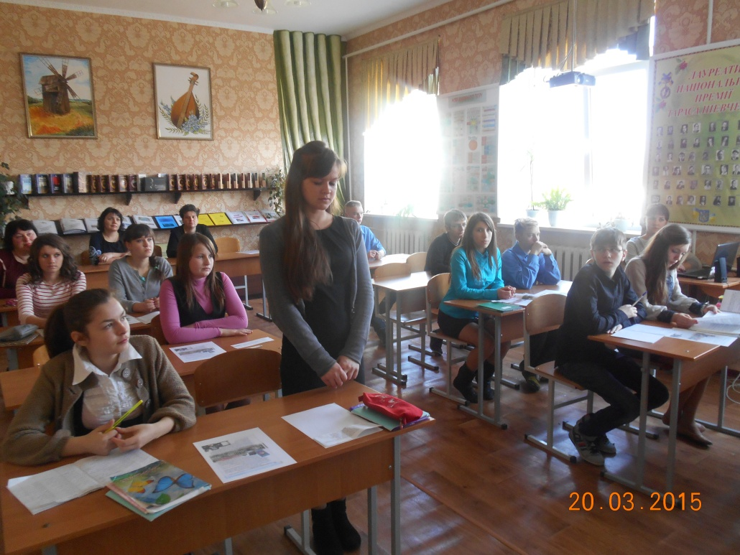
SPEAKING
- Ex.1, p.118
- Why do people go to museums?
- Which famous museums do you know? (The Louvre in Paris, The Metropolitan Museum of Art in New York City, The National Gallery in London)
- Which of museums have you visited?
- Exposition of which museum would you like to visit?
- What makes people create the works of art?
- What makes people collect them?
- What makes people go to see them in museums and other places?
- Who is your favorite painter?
- Do you know any British Museums?
Vocabulary
1. Read and match the words with their definitions.
1. painting | a) a picture made using very small pieces of glass or stone
2. drawing | b) a picture made using paint
3. photograph | c) pots, bowls etc made of clay
4. mosaic | d) a work of art made of materials such as stone, metal, or wood
5. collage | e) a picture drawn with pencils or pens
6. sculpture | f) a picture made by sticking paper, cloth, or other pictures onto a surface
7. ceramics | g) a picture made using a camera

2. Match the words with similar meanings.
1.  2.  3.  4.  5.  6.  7.  8. | work of art  painting  artist  depict  art gallery  paint  type  prominent | a)  b)  c)  d)  e)  f)  g)  h) | draw  show  museum  outstanding  masterpiece  painter  picture  style
LISTENING
Before listening
T: If you have never been to museums you have missed a lot. What did you miss? A number of things: from ancient books in Ireland to modern architecture in Spain.
Let's go to the museum. Do you know where they are. Say where are their home places.
The National Gallery |  |  | London
The Museum of Western and Oriental Art |  |  | Kyiv
The State Tretiakov Gallery |  |  | Moscow
The Louvre | is | in | Paris
The British Museum |  |  | London
While listening
T: Watch the video
Teacher: London has an amazing gallery known as The National Gallery. This gallery boasts of some of the finest examples of European art, including paintings by Raphael, Manet, Leonardo Da Vinci, Renoir, and Monet. This gallery has a very large number of paintings and some of the most famous ones are: Sunflowers, by Vincent van Gogh, The Virgin of the Rocks, by Leonardo Da Vinci, and Venus and Mars, by Sandro Botticelli.
After listening
1. READING
Ex. 5, p. 11_Read a text
- Find facts about the dates and numbers.
- How many wings are there in the National Art Gallery?
SPEAKING
T: Act out a dialogue with a partner about visiting the National Art Gallery
The tasks for student 1:
- say what pictures and drawings you saw in it;
- what impressed you most of all;
- give your advice as for visiting.
The task for student 2:
- try to find out opening hours;
- ask the names of the artists your friend saw in the museum;
- thank for the information.
GRAMMAR POINT
T: It's high time to refresh grammar material and train it in practice. Why do we use the Past Perfect tense? Give the examples, please.
(Students revise the rule and read the sentences.)
T: When is the Past Perfect Continuous tense used?
Choose the correct tense form to complete the sentences.
T: Look at the board, read and complete the sentences according to grammar rules you'd revised.
1. They_________(paint) for a few hours before their parents arrived.
2. They ______________ (mix colours) for a few minutes before their friends came in.
3. They______________ (look through the large book of masterpieces) for a few days before they visited the Louvr.
4. They_______________(be) amazed. They___________(see, never) such a beautiful canvas.
5. John___________ (be) upset because his picture___________ (not display).
6. The exhibition ____________(already, start) when we __________ (arrive) at the museum.
Key: 1. had been painting; 2. had been mixing colours; 3. had been looking through the large book of masterpieces; 4. were, had never seen; 5. was, had not been displayed; 6. had already started, arrived.
III. SUMMING-UP, HOME ASSIGNMENT
T: Our lesson of virtual visiting the museums is coming to an end. What did you like most of all in today's lesson? (Students answer)
T: I liked your work during the lesson.
Remember a very popular proverb "There are painters who transform the sun to a yellow spot, but there are-others who with the help of their art and their intelligence transform a yellow spot into the sun".
I wish you to enjoy the life and its beauty. Transform a yellow spot into the sun, a green spot into the grass and a blue colour to paint the sky blue!
Your home task for the next lesson is to learn the information about the National Gallery in London using the Internet resource.

Vocabulary
1. Read and match the words with their definitions.
1. painting | a) a picture made using very small pieces of glass or stone
2. drawing | b) a picture made using paint
3. photograph | c) pots, bowls etc made of clay
4. mosaic | d) a work of art made of materials such as stone, metal, or wood
5. collage | e) a picture drawn with pencils or pens
6. sculpture | f) a picture made by sticking paper, cloth, or other pictures onto a surface
7. ceramics | g) a picture made using a camera

2. Match the words with similar meanings.
1.  2.  3.  4.  5.  6.  7.  8. | work of art  painting  artist  depict  art gallery  paint  type  prominent | a)  b)  c)  d)  e)  f)  g)  h) | draw  show  museum  outstanding  masterpiece  painter  picture  style

Vocabulary
1. Read and match the words with their definitions.
1. painting | a) a picture made using very small pieces of glass or stone
2. drawing | b) a picture made using paint
3. photograph | c) pots, bowls etc made of clay
4. mosaic | d) a work of art made of materials such as stone, metal, or wood
5. collage | e) a picture drawn with pencils or pens
6. sculpture | f) a picture made by sticking paper, cloth, or other pictures onto a surface
7. ceramics | g) a picture made using a camera

2. Match the words with similar meanings.
1.  2.  3.  4.  5.  6.  7.  8. | work of art  painting  artist  depict  art gallery  paint  type  prominent | a)  b)  c)  d)  e)  f)  g)  h) | draw  show  museum  outstanding  masterpiece  painter  picture  style

Vocabulary
1. Read and match the words with their definitions.
1. painting | a) a picture made using very small pieces of glass or stone
2. drawing | b) a picture made using paint
3. photograph | c) pots, bowls etc made of clay
4. mosaic | d) a work of art made of materials such as stone, metal, or wood
5. collage | e) a picture drawn with pencils or pens
6. sculpture | f) a picture made by sticking paper, cloth, or other pictures onto a surface
7. ceramics | g) a picture made using a camera

2. Match the words with similar meanings.
1.  2.  3.  4.  5.  6.  7.  8. | work of art  painting  artist  depict  art gallery  paint  type  prominent | a)  b)  c)  d)  e)  f)  g)  h) | draw  show  museum  outstanding  masterpiece  painter  picture  style

Vocabulary
1. Read and match the words with their definitions.
1. painting | a) a picture made using very small pieces of glass or stone
2. drawing | b) a picture made using paint
3. photograph | c) pots, bowls etc made of clay
4. mosaic | d) a work of art made of materials such as stone, metal, or wood
5. collage | e) a picture drawn with pencils or pens
6. sculpture | f) a picture made by sticking paper, cloth, or other pictures onto a surface
7. ceramics | g) a picture made using a camera

2. Match the words with similar meanings.
1.  2.  3.  4.  5.  6.  7.  8. | work of art  painting  artist  depict  art gallery  paint  type  prominent | a)  b)  c)  d)  e)  f)  g)  h) | draw  show  museum  outstanding  masterpiece  painter  picture  style

Vocabulary
1. Read and match the words with their definitions.
1. painting | a) a picture made using very small pieces of glass or stone
2. drawing | b) a picture made using paint
3. photograph | c) pots, bowls etc made of clay
4. mosaic | d) a work of art made of materials such as stone, metal, or wood
5. collage | e) a picture drawn with pencils or pens
6. sculpture | f) a picture made by sticking paper, cloth, or other pictures onto a surface
7. ceramics | g) a picture made using a camera

2. Match the words with similar meanings.
1.  2.  3.  4.  5.  6.  7.  8. | work of art  painting  artist  depict  art gallery  paint  type  prominent | a)  b)  c)  d)  e)  f)  g)  h) | draw  show  museum  outstanding  masterpiece  painter  picture  style

Vocabulary
1. Read and match the words with their definitions.
1. painting | a) a picture made using very small pieces of glass or stone
2. drawing | b) a picture made using paint
3. photograph | c) pots, bowls etc made of clay
4. mosaic | d) a work of art made of materials such as stone, metal, or wood
5. collage | e) a picture drawn with pencils or pens
6. sculpture | f) a picture made by sticking paper, cloth, or other pictures onto a surface
7. ceramics | g) a picture made using a camera

2. Match the words with similar meanings.
1.  2.  3.  4.  5.  6.  7.  8. | work of art  painting  artist  depict  art gallery  paint  type  prominent | a)  b)  c)  d)  e)  f)  g)  h) | draw  show  museum  outstanding  masterpiece  painter  picture  style

Vocabulary
1. Read and match the words with their definitions.
1. painting | a) a picture made using very small pieces of glass or stone
2. drawing | b) a picture made using paint
3. photograph | c) pots, bowls etc made of clay
4. mosaic | d) a work of art made of materials such as stone, metal, or wood
5. collage | e) a picture drawn with pencils or pens
6. sculpture | f) a picture made by sticking paper, cloth, or other pictures onto a surface
7. ceramics | g) a picture made using a camera

2. Match the words with similar meanings.
1.  2.  3.  4.  5.  6.  7.  8. | work of art  painting  artist  depict  art gallery  paint  type  prominent | a)  b)  c)  d)  e)  f)  g)  h) | draw  show  museum  outstanding  masterpiece  painter  picture  style

Vocabulary
1. Read and match the words with their definitions.
1. painting | a) a picture made using very small pieces of glass or stone
2. drawing | b) a picture made using paint
3. photograph | c) pots, bowls etc made of clay
4. mosaic | d) a work of art made of materials such as stone, metal, or wood
5. collage | e) a picture drawn with pencils or pens
6. sculpture | f) a picture made by sticking paper, cloth, or other pictures onto a surface
7. ceramics | g) a picture made using a camera

2. Match the words with similar meanings.
1.  2.  3.  4.  5.  6.  7.  8. | work of art  painting  artist  depict  art gallery  paint  type  prominent | a)  b)  c)  d)  e)  f)  g)  h) | draw  show  museum  outstanding  masterpiece  painter  picture  style

Vocabulary
1. Read and match the words with their definitions.
1. painting | a) a picture made using very small pieces of glass or stone
2. drawing | b) a picture made using paint
3. photograph | c) pots, bowls etc made of clay
4. mosaic | d) a work of art made of materials such as stone, metal, or wood
5. collage | e) a picture drawn with pencils or pens
6. sculpture | f) a picture made by sticking paper, cloth, or other pictures onto a surface
7. ceramics | g) a picture made using a camera

2. Match the words with similar meanings.
1.  2.  3.  4.  5.  6.  7.  8. | work of art  painting  artist  depict  art gallery  paint  type  prominent | a)  b)  c)  d)  e)  f)  g)  h) | draw  show  museum  outstanding  masterpiece  painter  picture  style

Vocabulary
1. Read and match the words with their definitions.
1. painting | a) a picture made using very small pieces of glass or stone
2. drawing | b) a picture made using paint
3. photograph | c) pots, bowls etc made of clay
4. mosaic | d) a work of art made of materials such as stone, metal, or wood
5. collage | e) a picture drawn with pencils or pens
6. sculpture | f) a picture made by sticking paper, cloth, or other pictures onto a surface
7. ceramics | g) a picture made using a camera

2. Match the words with similar meanings.
1.  2.  3.  4.  5.  6.  7.  8. | work of art  painting  artist  depict  art gallery  paint  type  prominent | a)  b)  c)  d)  e)  f)  g)  h) | draw  show  museum  outstanding  masterpiece  painter  picture  style

1. They_________(paint) for a few hours before their parents arrived.
2. They ______________ (mix colours) for a few minutes before their friends came in.
3. They______________ (look through the large book of masterpieces) for a few days before they visited the Louvr.
4. They_______________(be) amazed. They___________(see, never) such a beautiful canvas.
5. John___________ (be) upset because his picture___________ (not display).
6. The exhibition ____________(already, start) when we __________ (arrive) at the museum.
1. They_________(paint) for a few hours before their parents arrived.
2. They ______________ (mix colours) for a few minutes before their friends came in.
3. They______________ (look through the large book of masterpieces) for a few days before they visited the Louvr.
4. They_______________(be) amazed. They___________(see, never) such a beautiful canvas.
5. John___________ (be) upset because his picture___________ (not display).
6. The exhibition ____________(already, start) when we __________ (arrive) at the museum.
1. They_________(paint) for a few hours before their parents arrived.
2. They ______________ (mix colours) for a few minutes before their friends came in.
3. They______________ (look through the large book of masterpieces) for a few days before they visited the Louvr.
4. They_______________(be) amazed. They___________(see, never) such a beautiful canvas.
5. John___________ (be) upset because his picture___________ (not display).
6. The exhibition ____________(already, start) when we __________ (arrive) at the museum.
1. They_________(paint) for a few hours before their parents arrived.
2. They ______________ (mix colours) for a few minutes before their friends came in.
3. They______________ (look through the large book of masterpieces) for a few days before they visited the Louvr.
4. They_______________(be) amazed. They___________(see, never) such a beautiful canvas.
5. John___________ (be) upset because his picture___________ (not display).
6. The exhibition ____________(already, start) when we __________ (arrive) at the museum.
1. They_________(paint) for a few hours before their parents arrived.
2. They ______________ (mix colours) for a few minutes before their friends came in.
3. They______________ (look through the large book of masterpieces) for a few days before they visited the Louvr.
4. They_______________(be) amazed. They___________(see, never) such a beautiful canvas.
5. John___________ (be) upset because his picture___________ (not display).
6. The exhibition ____________(already, start) when we __________ (arrive) at the museum.
1. They_________(paint) for a few hours before their parents arrived.
2. They ______________ (mix colours) for a few minutes before their friends came in.
3. They______________ (look through the large book of masterpieces) for a few days before they visited the Louvr.
4. They_______________(be) amazed. They___________(see, never) such a beautiful canvas.
5. John___________ (be) upset because his picture___________ (not display).
6. The exhibition ____________(already, start) when we __________ (arrive) at the museum.
1. They_________(paint) for a few hours before their parents arrived.
2. They ______________ (mix colours) for a few minutes before their friends came in.
3. They______________ (look through the large book of masterpieces) for a few days before they visited the Louvr.
4. They_______________(be) amazed. They___________(see, never) such a beautiful canvas.
5. John___________ (be) upset because his picture___________ (not display).
6. The exhibition ____________(already, start) when we __________ (arrive) at the museum.
1. They_________(paint) for a few hours before their parents arrived.
2. They ______________ (mix colours) for a few minutes before their friends came in.
3. They______________ (look through the large book of masterpieces) for a few days before they visited the Louvr.
4. They_______________(be) amazed. They___________(see, never) such a beautiful canvas.
5. John___________ (be) upset because his picture___________ (not display).
6. The exhibition ____________(already, start) when we __________ (arrive) at the museum.
1. They_________(paint) for a few hours before their parents arrived.
2. They ______________ (mix colours) for a few minutes before their friends came in.
3. They______________ (look through the large book of masterpieces) for a few days before they visited the Louvr.
4. They_______________(be) amazed. They___________(see, never) such a beautiful canvas.
5. John___________ (be) upset because his picture___________ (not display).
6. The exhibition ____________(already, start) when we __________ (arrive) at the museum.
1. They_________(paint) for a few hours before their parents arrived.
2. They ______________ (mix colours) for a few minutes before their friends came in.
3. They______________ (look through the large book of masterpieces) for a few days before they visited the Louvr.
4. They_______________(be) amazed. They___________(see, never) such a beautiful canvas.
5. John___________ (be) upset because his picture___________ (not display).
6. The exhibition ____________(already, start) when we __________ (arrive) at the museum.
1. They_________(paint) for a few hours before their parents arrived.
2. They ______________ (mix colours) for a few minutes before their friends came in.
3. They______________ (look through the large book of masterpieces) for a few days before they visited the Louvr.
4. They_______________(be) amazed. They___________(see, never) such a beautiful canvas.
5. John___________ (be) upset because his picture___________ (not display).
6. The exhibition ____________(already, start) when we __________ (arrive) at the museum.
1. They_________(paint) for a few hours before their parents arrived.
2. They ______________ (mix colours) for a few minutes before their friends came in.
3. They______________ (look through the large book of masterpieces) for a few days before they visited the Louvr.
4. They_______________(be) amazed. They___________(see, never) such a beautiful canvas.
5. John___________ (be) upset because his picture___________ (not display).
6. The exhibition ____________(already, start) when we __________ (arrive) at the museum.

